*Use the information in Chapter 11 (p.210-225) as well as the Bozeman podcast on* [*Signal Transduction in Pathways*](http://www.bozemanscience.com/038-signal-transduction-pathways) *to complete the reading guide.*

**Concept 11.2 Reception: A signaling molecule binds to a receptor protein, causing it to change shape**

Describe the relationship between a water-soluble ligand and a receptor protein.

Use Figure 11.7 (p.211) to label the following diagram, then summarize the events that must take place for a G-protein coupled receptor to function.

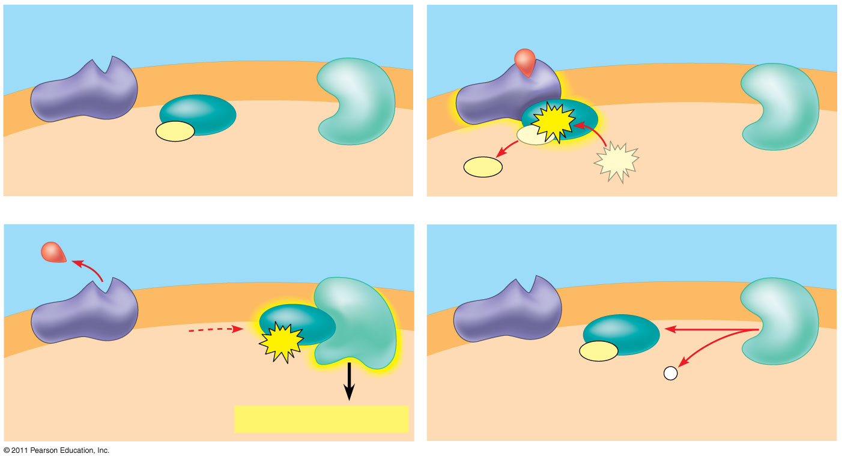

Use Figure 11.8 (p.212) to label the following diagram, then summarize the events that must take place for a receptor tyrosine kinase to function.

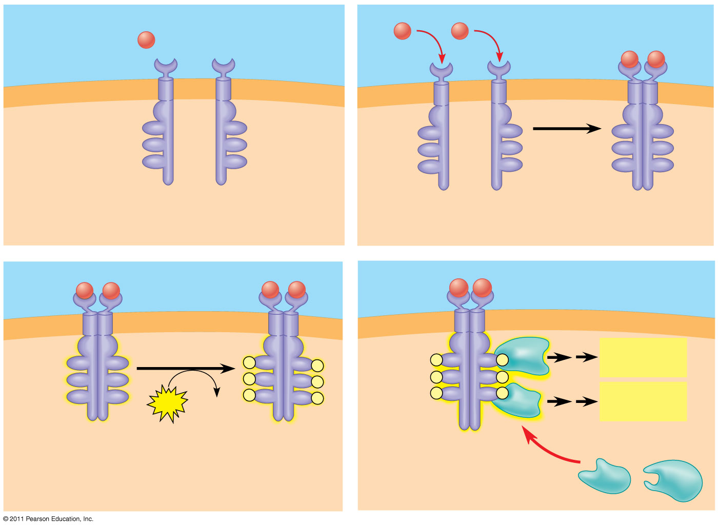

How does a RTK compare to a G-protein coupled receptor in terms of enzymatic activity and the number of transduction pathways that can be initiated?

Explain how a ligand-gated ion channel initiates an action potential. Draw a diagram to reinforce your explanation.

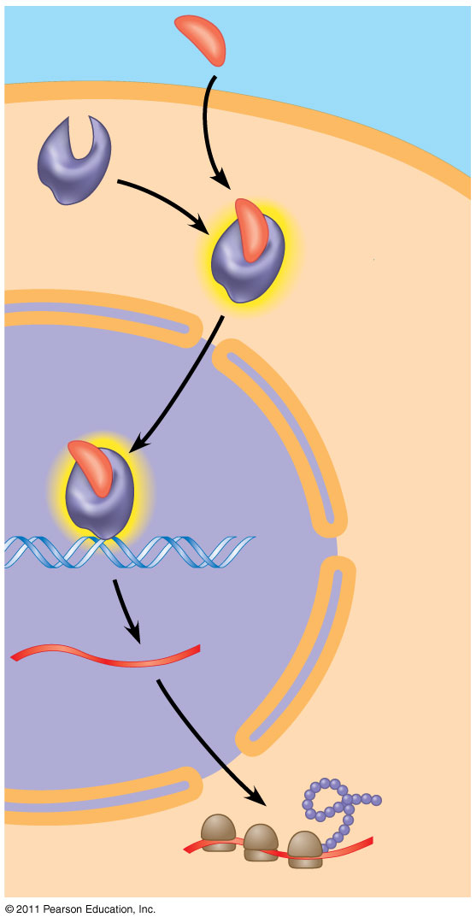Use Figure 11.9 (p.214) to label the following diagram, then summarize the events that must take place for an intracellular receptor to function.

**Concept 11.3 Transduction: Cascades of molecular interactions relay signals from receptors to target molecules in the cell**

Use Figure 11.10 (p.215) to label the following diagram, then summarize the events that must take place during a phosphorylation cascade.

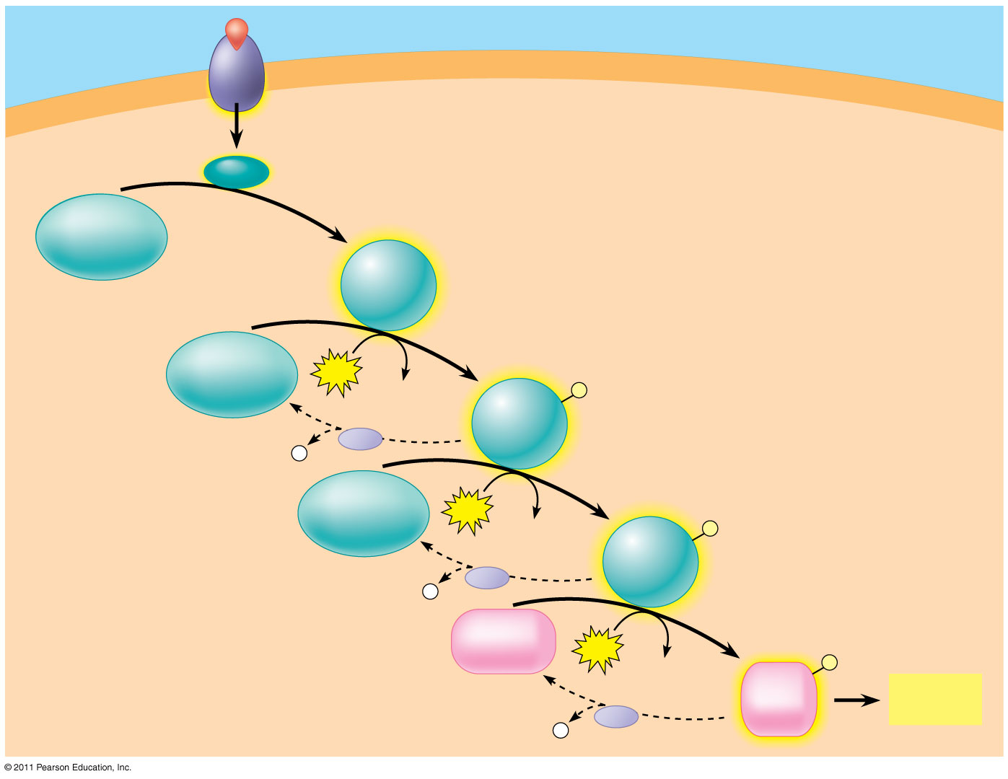

Use Figure 11.12 (p.217) to label the following diagram, then summarize how cyclic AMP works as a second messenger.

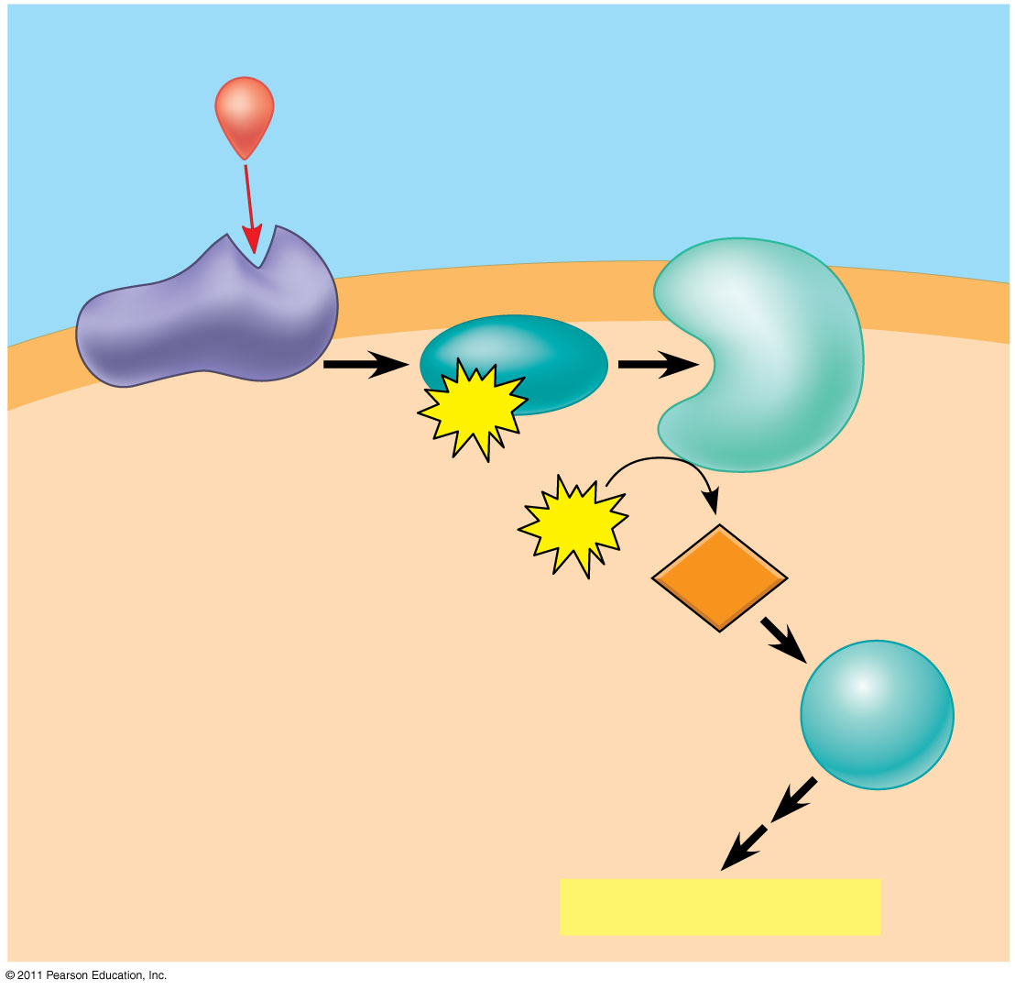

Explain how the toxin produced by the bacteria *Vibrio cholera* impacts the above pathway. You may also want to view Bozeman’s [Effects of Changes in Pathways](http://www.bozemanscience.com/039-effects-of-changes-in-pathways).

**Concept 11.4 Response: Cell Signaling leads to regulation of transcription or cytoplasmic activities**

Use Figure 11.17 (p.221) to label the following diagram, then summarize how signal transduction induces the directional cell growth of mating yeast cells.

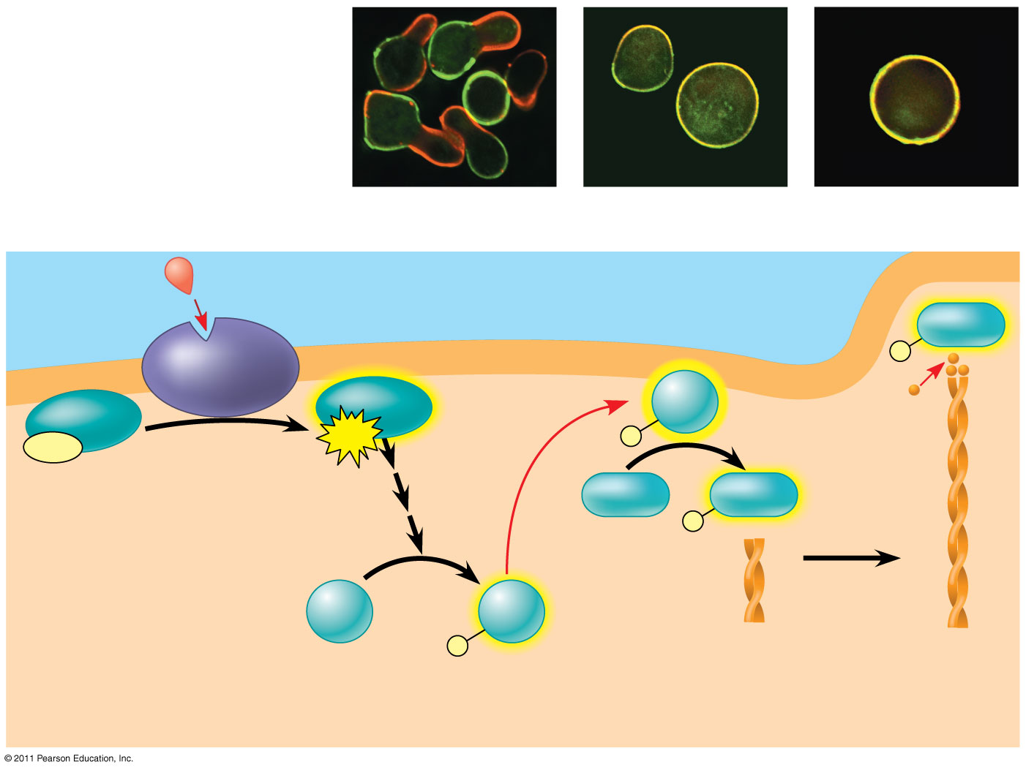

**Concept 11.5 Apoptosis integrates multiple cell-signaling pathways**

Use Figure 11.21 (p.224) to label the following diagram, then summarize how signal transduction induces apoptosis in *C. elegens*.

